EXHIBIT GUIDELINES
THE HONORABLE SUSAN JOHNSON - DEPT XXII

Please note: if exhibits are not in the correct format or do not follow these guidelines, they may not be accepted. Counsel will be required to resolve any issues before the start of trial.

- Please submit TWO sets of exhibits, one for the Court Clerk and one for the Judge; EXCEPTION: a copy for the Judge is not necessary if exhibits are to be displayed on video equipment (ELMO screen). The witness may only use the Clerk’s copy of exhibits during testimony.

- Please submit joint exhibits whenever possible. If exhibits are submitted separately as joint, please remove all duplicates. Counsel are encouraged to stipulate to exhibits where possible.
**Joint exhibits should be placed in a separate binder with a joint exhibit list.

Exhibits are to be identified by proposed exhibit numbers/letters according to the respective party, individually bates stamped, and placed in binders. Please use tabs to separate each exhibit. Plaintiff’s exhibits are numerical (ex: 1-35) and Defense exhibits are alphabetical (ex: A-K). In the event that the exhibits are voluminous, counsel can choose a block of numbers to use. For example: Plaintiff: 1-500; Defendant: 501-1,000.

Counsel are to mark each exhibit with a proposed exhibit label prior to the start of trial. Labels are to be placed on the first page, bottom right hand corner of each exhibit (example: see page # 3, attached).

EXHIBIT LISTS: Counsel to submit an exhibit list, identified as previously directed (see above), with a short description of each exhibit, one week before the start of trial (example: see page # 2, attached). Exhibit Lists MUST be in word format (.pdf, .jpg and .bmp will NOT be accepted).

PHOTOGRAPHS must be identified individually. DO NOT place several photos on one sheet of paper. (ex. If exhibit 7 consists of 3 photos, label them separately as 7a, 7b, and 7c).
DEMONSTRATIVE EXHIBITS such as blow-up’s and charts may be used; however, they are not generally marked as exhibits and do not go to the jury. If counsel would like the exhibit admitted, they are encouraged to submit a smaller, 8.5” x 11” size, copy that can be marked and easily reviewed by the jury as well as stored in the vault. If counsel insist that the LARGE version go to the jury, it must be marked separately.

DEPOSITIONS are not marked as an exhibit and they do not go to the Jury. If you want to publish a deposition the original must be submitted.

EQUIPMENT: Please contact the Court Recorder, Norma Ramirez, at 702.671.0572 to schedule an appointment for any audio/visual equipment.

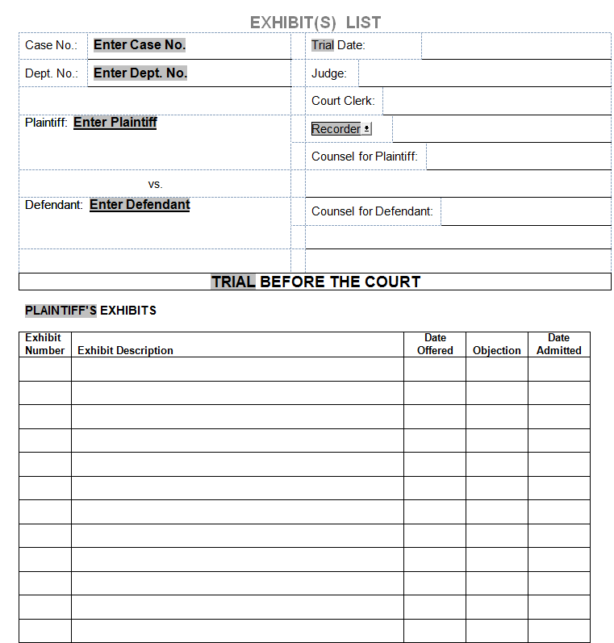

PLTF’S PROPOSED EXHIBITS  # _______________  Case No. |  | PLTF’S PROPOSED EXHIBITS  # _______________  Case No. |  | PLTF’S PROPOSED EXHIBITS  # _______________  Case No.
PLTF’S PROPOSED EXHIBITS  # _______________  Case No. |  | PLTF’S PROPOSED EXHIBITS  # _______________  Case No. |  | PLTF’S PROPOSED EXHIBITS  # _______________  Case No.
PLTF’S PROPOSED EXHIBITS  # _______________  Case No. |  | PLTF’S PROPOSED EXHIBITS  # _______________  Case No. |  | PLTF’S PROPOSED EXHIBITS  # _______________  Case No.
PLTF’S PROPOSED EXHIBITS  # _______________  Case No. |  | PLTF’S PROPOSED EXHIBITS  # _______________  Case No. |  | PLTF’S PROPOSED EXHIBITS  # _______________  Case No.
PLTF’S PROPOSED EXHIBITS  # _______________  Case No. |  | PLTF’S PROPOSED EXHIBITS  # _______________  Case No. |  | PLTF’S PROPOSED EXHIBITS  # _______________  Case No.
PLTF’S PROPOSED EXHIBITS  # _______________  Case No. |  | PLTF’S PROPOSED EXHIBITS  # _______________  Case No. |  | PLTF’S PROPOSED EXHIBITS  # _______________  Case No.
PLTF’S PROPOSED EXHIBITS  # _______________  Case No. |  | PLTF’S PROPOSED EXHIBITS  # _______________  Case No. |  | PLTF’S PROPOSED EXHIBITS  # _______________  Case No.
PLTF’S PROPOSED EXHIBITS  # _______________  Case No. |  | PLTF’S PROPOSED EXHIBITS  # _______________  Case No. |  | PLTF’S PROPOSED EXHIBITS  # _______________  Case No.

